PIZZA SALES SQL QUERIES ANALYSIS

**BY**

**Oladoyinbo Dada**

1. **KPI’s**
2. Total Revenue

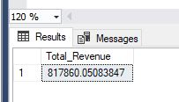SELECT SUM(total_price)AS Total_Revenue FROM pizza_sales;

1. Average Order Value:

SELECT SUM(total_price) / COUNT(DISTINCT order_id) as Avg_Order_Value from pizza_sales;

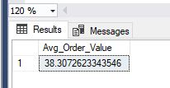

1. Total Pizzas Sold:

SELECT SUM(quantity) AS Total_Pizza_Sold from pizza_sales;

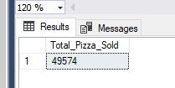

1. Total Orders:

SELECT COUNT(DISTINCT order_id) AS Total_Orders from pizza_sales;

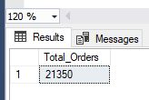

1. Average Pizza Per Order:

SELECT CAST(CAST(SUM(quantity) AS DECIMAL(10,2)) / CAST(COUNT(DISTINCT order_id) AS DECIMAL(10,2)) AS DECIMAL(10,2)) AS Avg_Pizzas_Per_Order from pizza_sales;

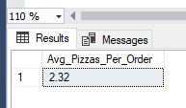

**SECTION B CHART QUERIES ANALYSIS**

1. Daily Trends:

SELECT DATENAME(DW, order_date) AS Order_Day, COUNT(DISTINCT order_id) AS Total_Orders FROM pizza_sales GROUP BY DATENAME(DW, order_date);

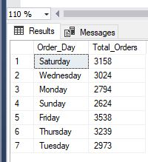

1. Hourly Trends:

SELECT DATEPART(HOUR, order_time) AS Order_Hours, COUNT(DISTINCT order_id) AS Total_Orders FROM pizza_sales GROUP BY DATEPART(HOUR, order_time)

ORDER BY DATEPART(HOUR, order_time);

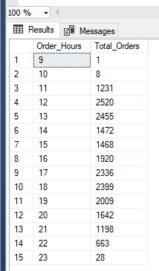

1. Percentage of Sales by Pizza Category:

SELECT pizza_category, SUM(total_price) * 100 / (SELECT SUM(total_price) from pizza_sales) AS Percent_of_TotalSales FROM pizza_sales GROUP BY pizza_category;

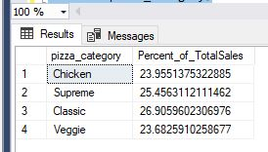

1. Percentage of sales by Pizza size:

SELECT pizza_size, As Total_Sales, SUM(total_price) * 100 / (SELECT SUM(total_price) from pizza_sales) AS Percent_of_TotalSales FROM pizza_sales GROUP BY pizza_size:

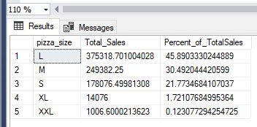

1. Total Pizza Sold by Pizza Category:

SELECT pizza_category, SUM(quantity) AS Total_Pizzas_Sold from pizza_sales GROUP BY pizza_category;

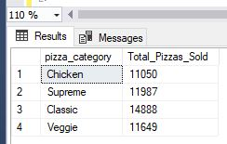

1. Top 5 best sellers by Total pizza sold:

SELECT TOP 5 pizza_name, SUM(quantity) AS Total_Pizzas_Sold

FROM pizza_sales GROUP BY pizza_name ORDER BY SUM(quantity) DESC

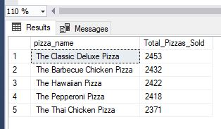

1. Bottom 5 worst-sellers by total Pizza sold:

SELECT TOP 5 pizza_name, SUM(quantity) AS Total_Pizzas_Sold FROM pizza_sales GROUP BY pizza_name ORDER BY SUM(quantity) ASC

